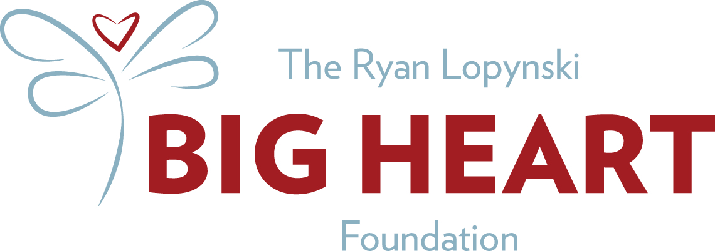

Dear Parent and Student:
We are excited to announce a free EKG screening established to honor the life of Ryan Davis Lopynski. A Robinson High School graduate, Fairfax County athlete, Virginia Tech freshman and friend to so many, Ryan unexpectedly collapsed at his home on April 26, 2009. He was a seemingly healthy 18-year old, who died of Sudden Cardiac Arrest (SCA) without warning. Out of this tragedy, the Ryan Lopynski Big Heart Foundation was established to honor his memory, and to increase public awareness of Sudden Cardiac Death through education and action.
One of our missions is to screen teen athletes in hopes of preventing other families from experiencing the same unnecessary loss. With the continued dedication of cardiologists, technicians and volunteers, we have established a program for our screenings. It takes less than 10 minutes and is pain free!
To Do: Please complete THE CARDIAC PERMISSION FORM AND WAIVER, and bring it with you to the screening. No one will be admitted to the screening without a parent/guardian and this form.
What to wear: On the day of the screening, girls should wear a sports bra, t-shirt and sweat pants or sport shorts. Boys should wear t-shirt and sweat pants or sports shorts. Girls will be asked to remove t-shirt but will keep sports bra on at all times, as well as shorts/sweats. Boys and girls will wear shorts/sweats at all times.
What to expect: Small patches will be placed on the student’s chest, legs and arms. Electrodes are attached to the patches, and the hearts electrical activity is recorded. A team of volunteer cardiologists and technicians will be on site. Only female technicians will test girls and they will be screened in a separate area than boys. Other volunteers will include members from the community. You, as parents or guardians, may wish to volunteer as well. The entire process should take approximately 10-15 minutes per student, and you can expect to get the results of your child’s screening the same day.

The purpose of an EKG: A simple EKG, when used to screen physically active young persons, can detect certain serious heart conditions. Recording the electrical activity of the heart by using electrodes attached to the skin with a mild adhesive, can detect a variety of abnormalities or “markers” that are associated with sudden cardiac death and not detected by a stethoscope. Please note that EKG screenings result in approximately 2% of the tests being falsely positive. This may require additional evaluation and testing by your physician. We believe that the benefit of this potentially life saving screening outweighs this concern.
How to prepare: We encourage you to discuss this screening with your child. We want to assure you that students’ confidentiality, privacy and individual modesty will be respected throughout all aspects of the program.
Thank you for your participation!
The Ryan Lopynski Big Heart Foundation

PO Box 301
Clifton, Va. 20124
www.ryanlopynski.org
Info@ryanlopynski.org

